SUPPLY CHAIN
ANALYSIS
A Data Analytics Project Using Python

Detailed Project Report

Prepared from the supplied Jupyter Notebook and project findings

Executive Summary
This project analyses supply-chain order and delivery data to understand shipping performance, delivery delays, profitability patterns, and operational factors associated with late deliveries. The analysis is implemented in Python using Pandas, NumPy, Matplotlib, and Seaborn in a Jupyter Notebook.
After removing cancelled shipments and preparing date fields, the notebook analyses 11,323 orders. It identifies 6,304 orders as delayed under the project's calculated delay definition, giving a late-delivery rate of 55.67%. The corresponding on-time/not-late share is 44.33%. The notebook also classifies orders by whether Order Profit Per Order is positive, negative, or zero, and compares profit metrics across delay values.
KPI | Reported value | Interpretation
Orders analysed | 11,323 | Rows remaining after cancelled shipments were excluded.
Late deliveries | 6,304 | Orders with calculated Delay > 0.
Late-delivery rate | 55.67% | Share of analysed orders classified as late.
Not-late rate | 44.33% | Share with calculated Delay <= 0; includes early and on-schedule orders.
90th percentile of delay among late orders | 3 days | 90th percentile calculated only on rows where Delay > 0.
Sum of positive Order Profit Per Order values | $488.3K | Positive order-profit values summed by the notebook.
Sum of Order Profit Per Order for delayed orders | $127.1K | The code labels this as loss due to delays, but it is a sum for delayed orders, not an isolated loss calculation.

Note: Values above are based on saved notebook outputs and the findings supplied by the project author. They have not been recalculated against the original CSV because the CSV was not supplied.

1. Project Introduction
Supply-chain performance depends on how accurately orders are processed, shipped, and delivered against the schedule promised to customers. Delays can affect customer experience and may be associated with differences in order profitability. Analysing historical order records can help identify where delays are concentrated and which operational dimensions deserve further investigation.
This project uses exploratory data analysis (EDA) to study the relationship between scheduled shipping time, actual shipping time, calculated delay, order profitability, geography, shipping mode, payment type, product department, and order timing.

2. Problem Statement
The project aims to describe delivery performance across the available supply-chain records, quantify the frequency of late orders, examine how delay varies by operational and time-based categories, and explore how order-profit values differ across delay groups. The analysis is descriptive: it identifies patterns in the available data but does not establish that any one factor causes delays or profit changes.

3. Project Objectives
- Load and inspect the supply-chain dataset using Python.
- Remove selected columns that are not required for the planned analysis and exclude cancelled shipments.
- Convert order and shipping date fields to datetime format.
- Create derived variables for processing time, delay, late-delivery status, order month, weekday, and order hour.
- Summarise order volume, late-delivery rate, delay percentiles, and profitability classification.
- Compare delay rates across regions, shipping modes, customer segments, departments, order types, and order status.
- Explore the relationship between delay, late-delivery risk, and order-profit values.
- Review monthly sales and profit patterns and document potential areas for operational follow-up.

4. Dataset Description
The notebook loads a CSV file named DataCoSupplyChainDataset.csv using Pandas read_csv with latin-1 encoding. The saved output shows an initial dataset shape of 11,943 rows and 53 columns. After selected columns are dropped and rows with Delivery Status equal to 'Shipping canceled' are excluded, the working dataset contains 11,323 rows and 20 columns at that stage; additional derived columns are then added.
Data area | Examples of columns used
Delivery performance | Days for shipping (real), Days for shipment (scheduled), Delivery Status, Late_delivery_risk, Shipping Mode
Order timing | order date (DateOrders), shipping date (DateOrders), Order Processing Time, Delay, order_month, order_day, order_hour
Profit and sales | Order Profit Per Order, Order Item Profit Ratio, Sales, Sales per customer, Product Price
Operational categories | Order Region, Customer Segment, Department Name, Category Name, Type, Order Status

Note: The notebook drops several identifiers, location fields, customer personal-information fields, and other columns not used in the final analysis. The full original CSV was not included with the notebook upload.

5. Tools and Technologies
Tool / library | Use in the project
Python | Main programming language for data analysis.
Pandas | Loading CSV data, filtering records, converting dates, grouping, aggregation, and KPI calculation.
NumPy | Creating the profitability classification using nested np.where conditions.
Matplotlib | Building charts, axes, labels, annotations, and monthly trend plots.
Seaborn | Histograms, bar plots, scatter plots, and correlation heatmap.
Jupyter Notebook / Google Colab path | Interactive environment for running analysis cells and viewing outputs.

6. Methodology and Data Preparation

6.1 Importing libraries and setting visual style
The notebook imports Pandas, NumPy, Matplotlib, Seaborn, Matplotlib ticker utilities, and warning filters. It sets a white-grid plotting style and uses a Viridis-inspired palette for visual consistency.

6.2 Loading and inspecting the dataset
The CSV is loaded with pd.read_csv(..., encoding='latin-1'). The notebook inspects the first records, column names, dataset shape, missing-value counts, duplicate rows, descriptive statistics, and category counts for columns with fewer than ten unique values.
The saved output reports zero fully duplicated rows at the point where duplicates are checked. The initial missing-value check reports no missing values in the displayed columns. Date conversion uses errors='coerce', which can turn unparseable dates into missing datetime values; the notebook does not show a dedicated post-conversion count of those newly missing dates.

6.3 Selecting columns and excluding cancelled shipments
A predefined list of columns is dropped, including customer names/contact fields, some identifiers, several location fields, and other columns not required for this analysis. Rows whose Delivery Status is 'Shipping canceled' are then removed. The saved notebook output shows the working data reduced from 11,943 rows to 11,323 rows.

6.4 Converting date fields
The shipping date and order date columns are converted to datetime using the format '%m/%d/%Y %H:%M'. This enables calculation of elapsed days and extraction of month, weekday, and hour.

6.5 Creating derived variables
Variable | Notebook logic | Meaning
Order Processing Time | Shipping date − order date, in whole days | Elapsed whole-day difference between the recorded shipping and order timestamps.
Delay | Order Processing Time − Days for shipment (scheduled) | Negative values indicate earlier than scheduled; zero indicates matching the schedule; positive values indicate delay.
Is_Delayed | Delay > 0 | Boolean indicator used to count late orders.
order_month | Month extracted from order date | Used for monthly delay, sales, and profit trends.
order_day | Weekday name extracted from order date | Used to compare delay rate by weekday.
order_hour | Hour extracted from order date | Used to compare delay rate by order hour.
Profitability Flag | Profit if profit > 0; Loss if profit < 0; Break point otherwise | Classification based on Order Profit Per Order.

Note: The project defines Delay from the order-to-shipping date difference rather than directly using the 'Days for shipping (real)' field. The report preserves that code definition.

7. Exploratory Data Analysis and Findings

7.1 Shipping-time patterns
In the notebook's value counts, 3,486 orders have a recorded actual shipping duration of 2 days, the largest single group. Actual shipping durations of 3, 4, 5, and 6 days have broadly similar counts, while 0- and 1-day shipping durations are comparatively uncommon. Scheduled shipment durations appear as 0, 1, 2, and 4 days, with 4 days being the most common scheduled duration (7,094 orders).

Actual shipping days | Order count
0 | 108
1 | 136
2 | 3,486
3 | 1,865
4 | 1,934
5 | 1,855
6 | 1,939

Scheduled shipping days | Order count
0 | 244
1 | 1,530
2 | 2,455
4 | 7,094

7.2 Delay distribution
The calculated Delay variable ranges from −2 to +4 days in the saved group summary. The largest group is +1 day of delay, accounting for approximately 30.1% of analysed orders. On-schedule orders (Delay = 0) account for about 19.2%; two days early account for about 13.0%; one day early account for about 12.1%; two days late account for about 16.8%; and three- or four-day delays account for about 4.1% and 4.6%, respectively.
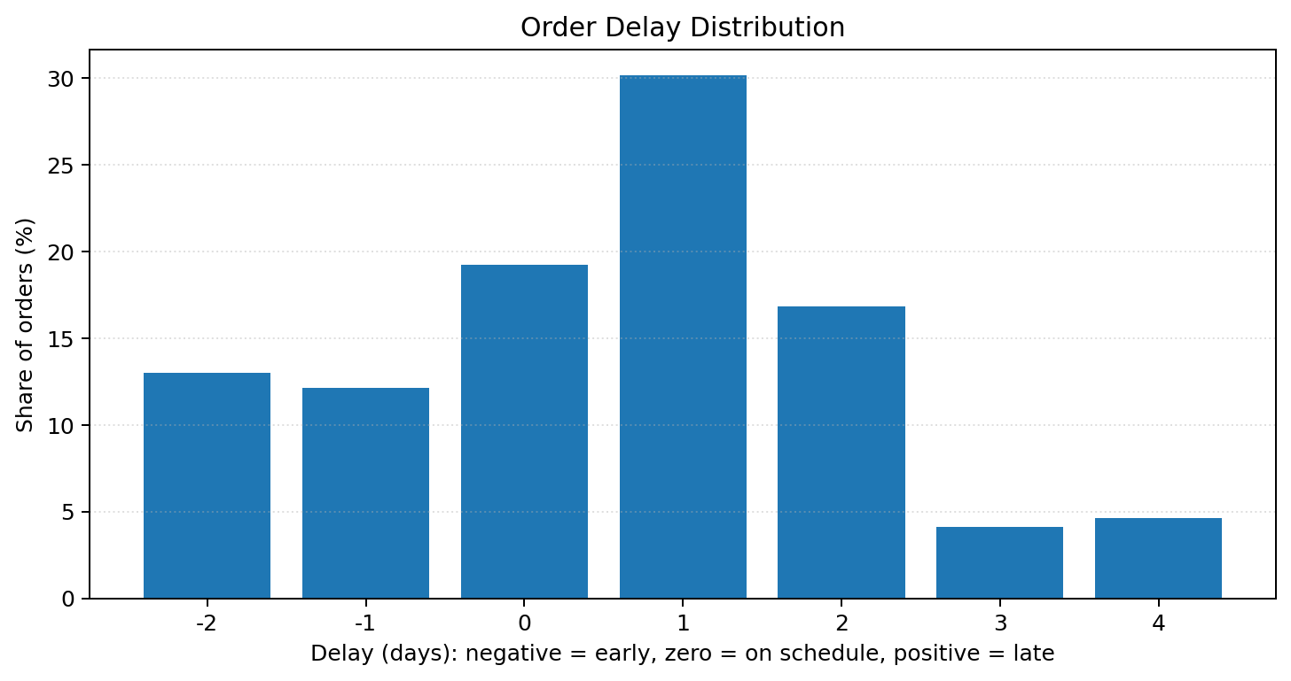
Note: Although the project notes describe the distribution as nearly normal, the saved frequency table is discrete and peaks at +1 day. A formal normality test or a fitted distribution would be needed to support a statistical normality claim.

7.3 Business KPIs
The notebook calculates 11,323 total analysed orders and 6,304 delayed orders. The late-delivery rate is 55.67%; the remaining 44.33% includes both on-schedule and early orders. Among the delayed orders, the 90th percentile of the Delay variable is 3 days.

7.4 Profitability classification
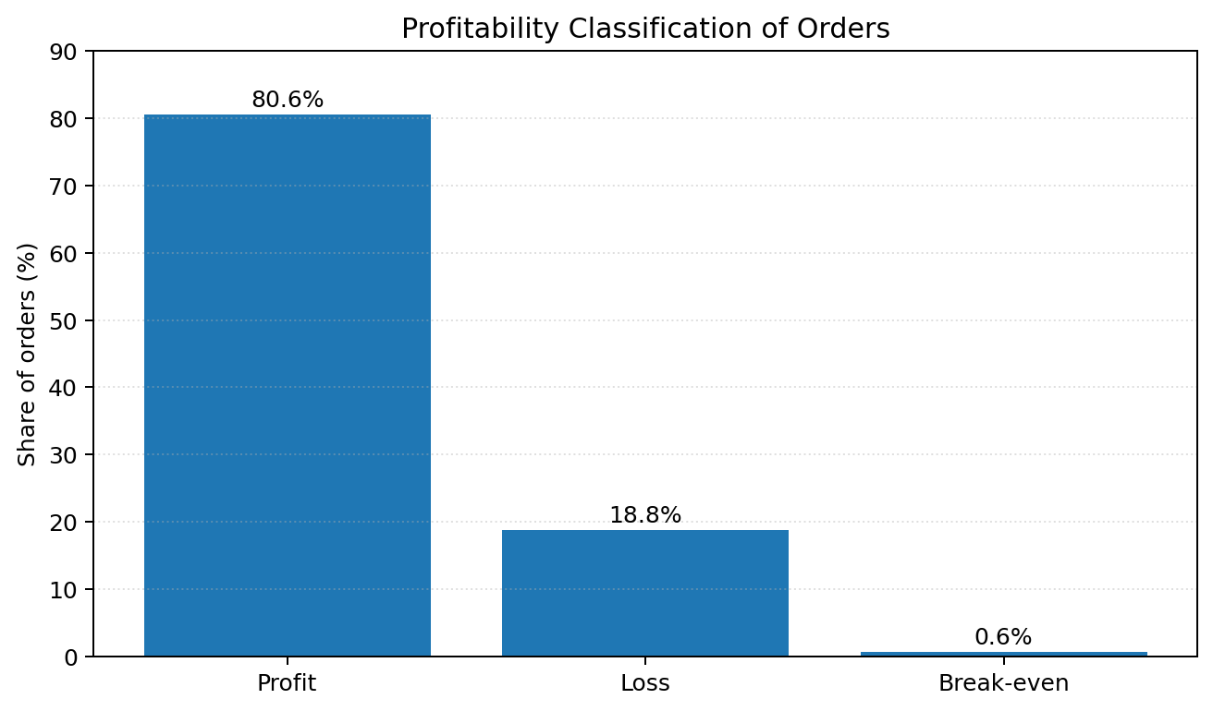
The profitability flag is created from Order Profit Per Order. The saved counts are 9,129 profitable orders, 2,129 loss-making orders, and 65 break-even orders. These correspond to approximately 80.6%, 18.8%, and 0.6% of the 11,323 analysed orders.

7.5 Average profit by delay value
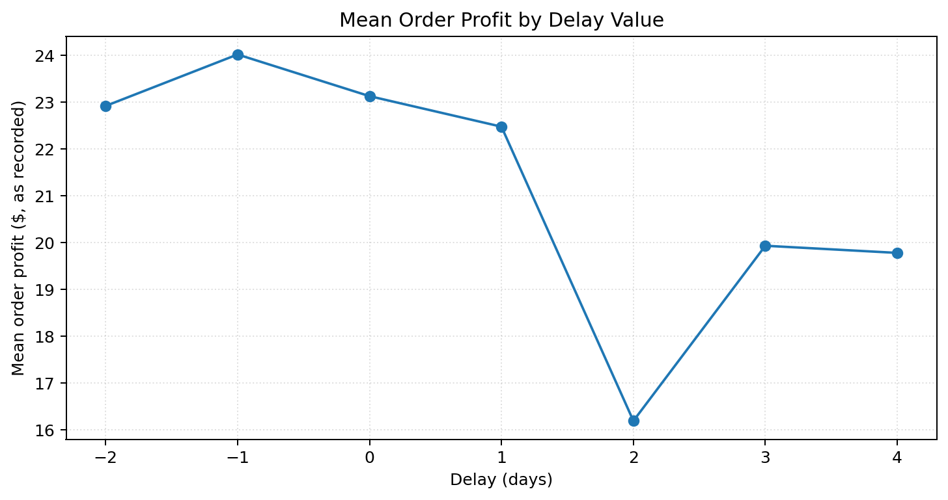
The group summary shows the highest mean Order Profit Per Order for orders one day early (Delay = −1), at approximately $24.01. The lowest mean is observed at a two-day delay (Delay = +2), at approximately $16.20. The mean profits for three- and four-day delays are similar, at about $19.93 and $19.78. These are descriptive group averages and do not prove that delay alone caused the profit differences.
Delay (days) | Mean profit ($) | Orders in group | Share of orders
−2 (2 days early) | 22.91 | 1,469 | 12.97%
−1 (1 day early) | 24.01 | 1,371 | 12.11%
0 (on schedule) | 23.12 | 2,178 | 19.24%
+1 | 22.47 | 3,413 | 30.14%
+2 | 16.20 | 1,903 | 16.81%
+3 | 19.93 | 465 | 4.11%
+4 | 19.78 | 523 | 4.62%

7.6 Regional and operational differences
The notebook calculates late-delivery percentages for the top categories within several dimensions, including Order Region, Customer Segment, Shipping Mode, Order Status, Type, and Department Name. It also creates a focused chart for Northern Europe to compare delay rates across shipping mode, customer segment, department, order type, and order status.
The project's recorded visual findings include:
- Northern Europe, East Africa, Southern Europe, East of USA, and Central Asia were reported to have delay rates around or above 60%.
- First Class shipping was reported as having a 100% delay rate in the analysed records; within Northern Europe, First Class was also reported at 100%, while Second Class was reported at 86.8%.
- Cash payment was reported with a 72.3% delay rate.
- The Technology department was reported with a 71.2% delay rate.
Note: These subgroup percentages are transcribed from the author's supplied interpretation of the charts. The saved notebook output does not expose the underlying subgroup tables as text, so the percentages have not been independently rechecked here. Small subgroup counts should be reviewed before operational decisions are made.

7.7 Calendar patterns
The notebook groups the Is_Delayed flag by order month, weekday, and hour, then plots the resulting rates. The project findings report the highest monthly delay rate in August (62.7%), a Tuesday delay rate of 58.0%, and a delay rate of 62.0% for orders placed at 20:00 (8 PM). These results describe the dataset and should be validated against order volumes in each group.
The project findings also report that monthly sales are higher in January, while profitability is higher in September and December. The notebook's final cell sums Sales and Order Profit Per Order by order month and plots the two measures separately.

7.8 Scheduled versus actual shipping and risk
The notebook includes a scatter plot comparing scheduled shipping days with actual shipping days, a numeric correlation heatmap, a scatter plot of actual shipping days against Order Processing Time, and a comparison of average profit for delayed versus non-delayed orders. The supplied findings state that calculated delay is approximately 81% correlated with Late_delivery_risk.
Note: Correlation indicates association, not causation. Also, the Late_delivery_risk field is present in the dataset and the heatmap uses numeric columns; the precise correlation coefficient should be confirmed directly from the heatmap or by printing corr.loc['Delay', 'Late_delivery_risk'] if that is the intended pair.
The supplied interpretation states that Days for shipping (real) and Order Processing Time are nearly linear, and that Order Processing Time is zero when actual shipping duration is 0 or 1 day. Since both variables are based on date/time or shipping-duration information, the exact relationship should be checked against the underlying rows and variable definitions before drawing further conclusions.

8. Key Insights
- Late deliveries are common in the analysed records: 55.67% of orders are classified as delayed using Delay > 0.
- A one-day delay is the most frequent delay value, representing approximately 30.1% of all analysed orders.
- Most orders have positive Order Profit Per Order, but about 18.8% are classified as loss-making under the project's profitability rule.
- Average order profit is lower for the two-day-delay group than for the other delay groups shown in the saved summary.
- The supplied chart interpretation identifies differences by region, shipping mode, payment type, department, month, weekday, and order hour; these categories can guide deeper investigation.
- Monthly sales and monthly profit do not peak in the same months according to the project interpretation, suggesting that sales volume and profitability should be tracked separately.

9. Recommendations
The following are analytical follow-up recommendations based on the patterns observed; they are not tested interventions:
- Investigate the one-day and two-day delay groups first, as they contain substantial order volume and the two-day-delay group has the lowest mean profit in the saved summary.
- Review First Class and Second Class delivery records by region, including the number of orders in each subgroup, before concluding that a shipping mode is consistently unreliable.
- Examine Technology department and cash-payment orders for operational differences such as processing steps, fulfilment location, carrier assignment, and order mix.
- Compare monthly, weekday, and hourly delay rates with the number of orders per group to distinguish a high percentage from a high absolute number of delayed orders.
- Build a dashboard with total orders, late-delivery rate, average delay, on-time rate, positive-profit share, and delayed-order profit summaries, with filters for region, shipping mode, department, and date.
- If predictive analysis is a future goal, separate the target variable from any features that directly encode the delivery outcome to reduce data leakage.

10. Limitations and Validation Notes
- The notebook's metric named 'Total Loss due to delays' sums Order Profit Per Order across all delayed orders. It does not isolate negative profit values or estimate the counterfactual profit that would have occurred without a delay. The $127.1K figure should therefore be described as the sum of recorded order-profit values for delayed orders unless a separate loss methodology is implemented.
- The reported $488.3K total profit is calculated by summing positive Order Profit Per Order values only; it is not the net profit after subtracting loss-making orders.
- The on-time delivery percentage is calculated as 1 − delayed orders / total orders. As Delay <= 0 includes early orders, the 44.33% figure is more precisely a not-late share rather than strictly the share delivered exactly on schedule.
- The Delay variable is based on whole-day timestamp subtraction and scheduled days. It may differ from the dataset's Delivery Status or Late_delivery_risk labels, which are separate fields.
- Date conversion uses errors='coerce'. The notebook should explicitly check for NaT values after conversion and inspect any affected rows.
- Subgroup delay rates such as 100% First Class delay should be accompanied by subgroup order counts to avoid over-interpreting small groups.
- Correlation does not prove cause and effect. The reported approximately 0.81 correlation should be tied to a clearly named pair of columns and checked directly from the correlation matrix.
- The normality description of delay distribution should be treated as visual interpretation rather than a verified statistical result.

11. Future Scope
- Add a dedicated validation section that compares calculated Delay with Delivery Status and Late_delivery_risk.
- Create a reproducible summary table for each category with total orders, delayed orders, delay percentage, average delay, and average profit.
- Use confidence intervals or minimum-count thresholds when comparing small subgroups.
- Develop a Power BI or Streamlit dashboard to make the delivery KPIs and category comparisons interactive.
- Test whether factors such as shipping mode, region, department, scheduled duration, order hour, and order weekday remain associated with delay after controlling for other variables.
- If building a machine-learning model, use a time-aware or grouped train/test split where appropriate, evaluate class imbalance, and report metrics such as precision, recall, F1-score, ROC-AUC, and a confusion matrix.

12. Conclusion
This supply-chain analysis uses Python-based exploratory data analysis to describe order fulfilment, delivery delay, and profitability patterns in 11,323 analysed orders. The notebook identifies 6,304 delayed orders, corresponding to a late-delivery rate of 55.67%, while 44.33% of orders are not classified as late under the calculated Delay rule. The most common delay value is one day late, and the 90th percentile of delay among late orders is three days.
The profitability classification indicates that approximately 80.6% of orders have positive recorded order profit, 18.8% have negative recorded order profit, and 0.6% are at break-even. Mean profit varies across delay groups: it is highest for orders shipped one day earlier than scheduled and lowest for the two-day-delay group in the saved summary. The analysis also highlights potential differences by region, shipping mode, payment type, department, month, weekday, and order hour.
Overall, the project demonstrates how data cleaning, date-time feature engineering, aggregation, and visualisation can turn raw supply-chain records into useful operational insights. The findings can help prioritise further investigation, but the subgroup patterns and profit relationships should be validated with the original data and interpreted as associations rather than causal effects. A next iteration should improve KPI definitions, verify subgroup counts, and make the analysis reproducible.

Appendix A. Important Code Logic

Load data
df = pd.read_csv("DataCoSupplyChainDataset.csv", encoding="latin-1")

Exclude cancelled shipments
df = df[df["Delivery Status"] != "Shipping canceled"]

Convert dates
df["shipping date (DateOrders)"] = pd.to_datetime(df["shipping date (DateOrders)"], format="%m/%d/%Y %H:%M", errors="coerce")
df["order date (DateOrders)"] = pd.to_datetime(df["order date (DateOrders)"], format="%m/%d/%Y %H:%M", errors="coerce")

Create processing time and delay
df["Order Processing Time"] = (df["shipping date (DateOrders)"] - df["order date (DateOrders)"]).dt.days
df["Delay"] = df["Order Processing Time"] - df["Days for shipment (scheduled)"]
df["Is_Delayed"] = df["Delay"] > 0

Classify profitability
df["Profitability Flag"] = np.where(df["Order Profit Per Order"] > 0, "Profit", np.where(df["Order Profit Per Order"] < 0, "Loss", "Break point"))

Aggregate profit by delay
profit_metrics = df.groupby("Delay")["Order Profit Per Order"].agg(mean_profit="mean", total_profit="sum", order_count="count").reset_index()

Appendix B. Metric Definitions
Metric | Definition used in the notebook
Delay | Order Processing Time minus Days for shipment (scheduled).
Late delivery | Delay greater than zero.
Not-late share | One minus late-order count divided by total analysed orders.
90% delay (days) | 90th percentile of Delay among rows where Delay is greater than zero.
Profitability flag | Profit if Order Profit Per Order > 0; Loss if < 0; Break point if equal to 0.
Total Profit KPI | Sum of Order Profit Per Order values greater than zero.
'Total Loss due to delays' KPI | Sum of Order Profit Per Order for all rows with Delay > 0; naming should be revised because this does not calculate loss alone.

